Date: August 29, 2019
To: Participating Mortgage Revenue Bond (MRB) Lenders/Servicers
From: Betty Temple-Putnam, Sr. Vice President of Single-Family Programs
Re: MRB7 Program Bulletin #11 –

- Revisions to the MRB7 Program Guidelines for Fannie Mae Home Ready &/or HFA Preferred & Freddie Mac Home Possible Conventional Loans
- Revision to the MRB7 Checklist (Compliance Package)

This bulletin serves to notify participating MRB lenders that effective with reservations taken on or after Tuesday, September 3rd, MHC will no longer allow Fannie Mae conventional loan reservations within the MRB program unless the borrowers meet the new Home Ready &/or HFA Preferred or the Freddie Mac Home Possible (not selecting the HFA Advantage Loan Product Identifier code in LPA) 80% or below AMI limits set by FHFA and also cannot exceed the current MRB household income limits, regardless of loan type. To verify if your loan meets the new HomeReady or Home Possible (not using the Freddie Mac HFA Advantage product) AMIs, go to either link highlighted below to access the

https://homeready-eligibility.fanniemae.com/homeready/

Or

If not using the Freddie Mac HFA Advantage Product:

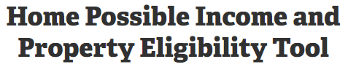https://sf.freddiemac.com/working-with-us/affordable-lending/home-possible-eligibility-map

Input your property address to see the applicable 80% AMI – Example provided below:

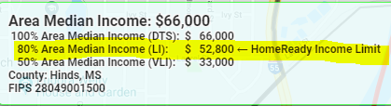

Also effective with reservations taken on or after September 3, 2019 for all loan types, MHC will require that the Automated Underwriting Findings (DU/DO/LPA/GUS, whichever is applicable) be uploaded to MHC’s online reservation system portal using the “AUS” Index sheet as a part of the MRB Compliance Package. The MRB Checklist has been revised and the previous checklist will be removed. The MHC Single-Family Underwriters will not condition the loans for the Automated UW Findings on loans that were reserved prior to 9/3/19.

The Freddie Mac Home Possible program must also follow the 80% or lower AMI if not coded using the Loan Product Identifier (LPI) code for the HFA Advantage program. If using the HFA Advantage product, lenders will not be required to use the AMIs set by FHFA. The lender will only be required to follow the MRB Income limits and the borrowers will continue to receive the reduced 18% MI, until further notice from Freddie Mac.

MHC will not allow a Fannie Mae HomeReady or HFA Preferred product loan where the Borrowers income exceeds the FHFA established 80% AMI in our MRB program.

Should you have any questions, contact me or any Single-Family Program Underwriter at 601.718.4642.

